**SZJ-ZN ROTARY TORQUE MEASURING SYSTEM**

**OPERATION MANUAL**

**Preface**

**——Thank you very much for ussing Petrokey products.**

**——Please read this manual carefully for your first operation. It will be helpful for you to make better use of the product. Operation against the instructions and requirements as stated in the manual may result in damage of the product or serious human injury**

**—— The manual is published by Hubei Jianghan Petroleum Instrument & Meter Co., Ltd. and has been carefully and strictly collated and checked. We will not guarantee that there is no error or imperfection at all in it.**

**——Hubei Jianghan Petroleum Instrument & Meter Co., Ltd. has always been devoted to the reform of product function and improvement of service quality. All the information contained in this document is subject to change without notice.**

**——The manual aims to help you make good use of Petroley products and all the statement, information and suggestion in the manual do not make up any expressed or implied guarantee. The pictures in this manual is only for reference and if any discrepancy exists compared to the actual one, please take the**

**later.**

**——This manual is an integral part of the product and please properly keep it for future reference at service time.**

**——For the places where special attention should be paid, the manual takes eye-catching signs to remind the operators. Meanings of the signs are as follows：**

**Caution：Inform the users to pay more attention to the notes following the sign. All the operation shall be performed according to the manual; improper operation may result in heavy human injuries and accidents.**

**Warning：Special attention shall be paid to the notes following the sign. Improper operation may cause serious damages to the product.**

**——No part of this document may be reproduced or copied or spreaded without the prior written consent of Hubei JPIM Co., Ltd. in any formats. You also cannot translate it into any other language without the prior written consent of Hubei JPIM Co., Ltd.**

**——SY® , Petrokey® ,**  **,**  **, JPIM® , Petron-Jianghan®、PTJH® are all registered trademarks of Hubei Jianghan Petroleum Instrument & Meter Co., Ltd.**

**——All the other trade marks mentioned in this document belong to their owners.**

**——In the case of any discrepancy between the actual condition of the product and the document during your operation, or you need the latest information, or you have any idea or suggestion for us, please call us or visit our website**

**Content**

**Preface 0**

**1 System introduction 1**

**1.1 Main technical specifications 1**

**1.2 System composition and working principle 1**

**2 Installation, adjustment and operation 2**

**2.1 Rotary Torque Sensor 2**

**2.2 Rotary torque gauge 4**

**2.3 Hose connection 4**

**2.4 Adjustment 5**

**1 System introduction**

**1.1 Main technical specifications**

**Working temperature：-30～65℃**

**Relative humidity：0～90%**

**Measuring range：0～45kN·m（display mode 0～500 scales）**

**Measurement error：≤±2.5%FS**

**1.2 System composition and working principle**

**Measuring unit of mechanical drilling rigs (driven by rotary chain) consists of idler rotary torque**

**sensor (Figure 1-1), rotary torque gauge (installed in the driller’s console), damper valve,**

**connecting hose, and etc. Rotary torque measuring unit obtains rotary torque indirectly by testing pull force of tight side of rotary drive chains. Install rotary torque sensor under tight side of drive chains. The idler of sensor forms an angle with the chains by jacking them up; when rotary table exerts a torque on the drill stem, the drive chains will produce downward pressure onto the idler, which has direct proportion to rotary torque. The pressure is transmitted to the bourdon tube of rotary torque gauge via hose of hydraulic system, and the free end of the tube thus begins to**

**move, which in turn drives the pointer to deflect by an amplifying mechanism to indicate rotary torque. Connection parts of sensor are shown hereunder:**

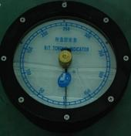

**Rotary torque gauge**

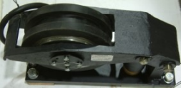

**Rotary torque sensor（idler type）**

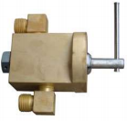

**Damper valve**

**Hydarulic hose**

**Rotary torque**

**Damper valve**

**torque**

**Rotary sensor**

**gauge**

**Figure 1-2 Shematic diagram of rotary torque measuring unit**

**Two rotary torque sensors of the same type can be installed for the measurement of torque rotating in clockwise and anti-clockwise directions. Users can choose to use one gauge or two gauges. When there is only one gauge, the operator has to switch between two sensors manually.**

**The key point for the use of the idler sensor is that there must be enough space in the chain box for installation and meet the requirements of the sensor ordered (e.g. single or dual chains, 2inches, 1.5inches or 1.75inches, etc.).**

**2 Installation, adjustment and operation**

**2.1 Rotary Torque Sensor**

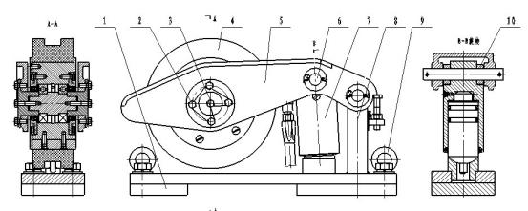

**Figure 2** **-1 Component drawing of idler rotary torque sensor**

**Breakdown drawing of idler rotary torque sensor**

|  |  |  |
| --- | --- | --- |
| **1** | **SZJ-ZN.1-9** | **Installation board** |
| **2** | **GB32.1-88** | **Eye bolt M8×18** |
| **3** | **GB32.1-88** | **Eye bolt M8×40** |
| **4** | **SZJ-ZN.4.1** | **Idler assembly** |
| **5** | **SZJ-ZN.4-2** | **Support arm** |
| **6** | **SZJ-ZN.1A-5** | **Pin shaft** |
| **7** | **SZJ-ZN.4.4** | **Piston assembly** |
| **8** | **SZJ-ZN.1.8** | **Support bracket** |
| **9** | **GB825-76** | **Lifting bolt M12** |
| **10** | **SZJ-ZN.1-16** | **Spacer** |

**There are two installation methods for rotary torque sensors for different drilling rigs. One method is to install it in a closed chain box; the other is in a half-closed chain box. The two installation methods are similar; the only difference is that users do not need to drill a hole in the half-closed box. So we take the closed chain box as an example, refer to Figure 2-1, 2-2 and Table 2-1 for detailed installation information.**

|  |
| --- |
| **Hydraulic elbow b~~end~~** |

**Figure 2-2 Installation drawing of idler type rotary torque sensor**

**a) The desired installation place for rotary torque sensor is the place under the tight side of**

**chains in the rotary drive chain box and the idler is placed in the middle of the drive and driven sprockets. The bottom plane of installation plate of sensor shall be parallel with centerline of the tight side of the chains (when the chains are pulled straightly), and the distance between them is 350mm. Free end of rocker arm of sensor points towards drive sprocket. Drill a**

**inspection windows (600mm×400mm) opposite to the sensor in the chain box and put sealing washer and a cover onto it (Must keep the original steel rigidity of chain box!). Drill another**

**hole (diameter: Φ28mm) next to the cylinder of sensor in the chain box to outlet hydraulic hose, and the edge and surface of the hole must be clean and flat.**

**b) Fasten the welding plate onto the base of sensor by bolts and nuts.**

**c) Put the sensor into the chain box and side of the sensor shall be opposite to the inspection window. Free end of the rocker arm of the sensor points towards drive sprocket.**

**d) Adjust position of the sensor until centers of idler, drive and driven sprockets are in the same plane. The chain roller sits on the flange of the idler and the users must be careful that the connection board of chains shall never touch the idler in case it may break the idler. Al last, weld the welding base plate well.The base plate is 130mm thick and shall sit in the middle of chain box bottom at welding.**

**e) Put the hydraulic bend onto the chain box.**

**2.2 Rotary torque gauge**

**a) Fix the driller’s console with rotary torque gauge in front of the driller so that the driller can view directly values of dials.**

**b) Connect the sensor with corresponding connector on the driller’s console with hydraulic hose.**

**c) Adjust rotary torque damper valve and fully open it.**

**d) Do not let chains touch the idler and adjust dial knob to make pointer points to zero; and then put down the chains**

**e) Connect a hand pump with the oil injection port of rotary torque (inside the driller’s console) and inject oil into the gauge. Meanwhile open the air exhaust valve and remove all the air in it. Close the valve till all the air has been eliminated. Continue to inject oil till rotary torque gauge reads 50~60.**

**f) Lock rotary table brake and carefully clutch on rotary table and make the chains produce a bigger pull force. The gauge should read 300~400. Otherwise you have to pump more oil into the hydraulic system or drain some oil, then repeat the operation.**

**2.3 Hose connection**

**a) Connect one end of the hydraulic hose (tagged “rotary torque gauge”, 10 or 15meters long)**

**to the hose of sensor and the other end to the connector tagged “rotary torque gauge” at the back of the driller’s console.**

**b) Open the air exhaust valve and inject oil from the back of driller’s console to the rotary**

**torque sensor and hydraulic hose. The air inside the copper hose and corresponding**

**hydraulic hoses will be exhausted (check if there are still air bubbles coming out). Then close the valve.**

**c) Inject some oil into the sensor when the hose is connected till rotary torque gauge reads 50~70. This is the initial value.**

**2.4 Adjustment**

**Connect a piston type pressure gauge with the rotary torque gauge and increase pressure of the gauge 0~6MPa. Increase pressure gradually with 1MPa for each step. Pressure value indicated by the rotary torque gauge shall be within 0~500 and no connection position leaks oil, pointer runs smoothly. Check again while reducing pressure.**

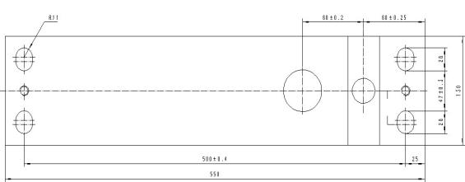

**Schematic diagram of sensor base**

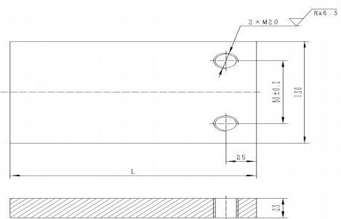

**Mounting board of sensor**