Please read this manual carefully before operation and installation.

**SZJ-DN Tong Torque Measuring System**

**Operation and Installation manual**

**SZJ-DN Tong Torque Measuring System**

**1. Structure and Working Principle**

The system is used for the measurement and display of tong torque changes during drilling operation and to help the driller to learn about the working status of drilling rig.

The measuring system consists of tong torque sensor, indicating gauge, damper valve and hoses, as shown in the following figure.

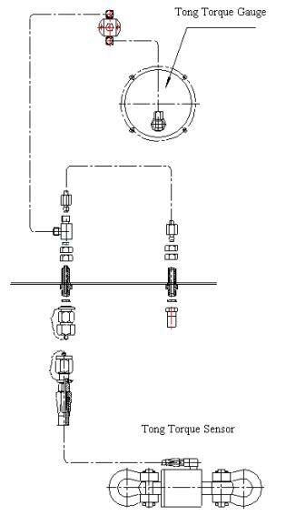

**Figure 1 System Diagram**

Working Principle:

Tong torque sensor is mounted at the tail line of tong. When the drill stem is screwed on, it produces a line pull force (F) on the tail line, which is proportional to the screw-on torque (M). The pull force works on the hydraulic oil via piston in the senor produces a hydraulic signal pressure (P), and then be transmitted to the bourdon tube of tong torque gauge via hydraulic hose, and the free end of the tube thus begins to move, which in turn drives the pointer to deflect by an amplifying mechanism to indicate the pull force on the tail line. We can use the following formulas to show their relationship:



M = F×L sin (α )

In which,

L— length of tong handle

D— inner diameter of piston cylinder

d— outer diameter of piston rod

α — inclination between tong and tail line

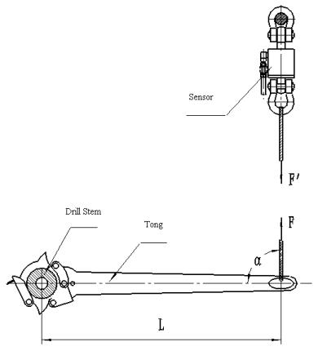

Figure 2 Tong Torque Measuring System

We can get from the above formula that oil pressure (P) is proportional to tong torque M or force (F) on the tail line. Torque M or force on the tail line F can be indicated on the evenly scaled gauge. Length of tong handle (L) is different for various types of tongs, so the unit on the tong torque gauge is not kN ·m, but kN.

Because of the easy relationship of line pull (F) and tong torque (M), it is easy to obtain torque (M) when we know force (F). Supposed α =90 °, L=1m, then the value of F is equal to that of M. To achieve that, when we install the sensor, try your best to keep the centerline of the tail line in its horizontal status and forms a 90-degree angle with tong handle when the senor is pulled. If the centerline of tail line is not vertical to the tong handle, you can obtain the moment with a formula and pull force value you read.

For the sake of easy operation, users can calculate the line pull force according to proper screw-on torque and tong handle, and then move the target pointer to corresponding position via the knob at the center of the dial. When the indicating pointer superposes the target pointer, stop screwing on.

**2. Technical Specifications**

1 Working Temperature: -30℃-70℃

2 Relative Humidity: 0-90%

3 Range: 0 - 100kN (tail line pull)

4 Error：≤±2.5%

**3. Installation, Adjustment and Operation**

**1 Tong Torque Sensor**

Install tong torque sensor on the tail line near the spud pile. The ring at the end of sensor cylinder can be tied directly to the spud pile. The ring at the piston rod end is tied to the tail line. Ring the slickline and knob it, and then fasten the slick line with rope clamp. Check if it has been well tied and clamped after installation. Try to keep the centerline of tail line in its horizontal status and forms a 90-degree angle with tong handle when the sensor is pulled.

**2 Tong Torque Gauge**

1) Mount tong torque gauge and damper valve at proper positions on the driller’s console. Connect the quick male connector of rubber hose on the sensor with the quick female connector (on the cross stay inside the driller’s console) on the damper valve. Adjust the valve rod of damper valve and completely open the damper valve.

2) Connect a hand pump to oil injection connector (on the cross stay inside the driller’s console) of tong torque and then open the air exhaust valve. Inject oil into the system until all the air in the system has been completely eliminated. Close the air-releasing valve and inject oil in to the system till the piston withdraws to the bottom of the sensor.

3) Adjust the valve rod (rotate clockwise to make the opening of valve become smaller) of damper valve so that tong torque pointer will not vibrate heavily.

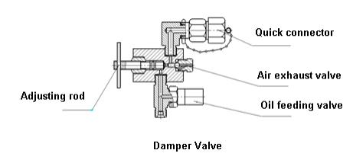

4) Calculate tail line pull in accordance with proper screw-on torque and length of tong handle. Move the target pointer to corresponding position via the knob at the center of the dial. When the yellow pointer superposes the target pointer, stop screwing on

**4.Maintenance**

1. Before moving the instrument, disconnect the hose first.

2. Keep the instrument clean and tidy. Please do not wash or clean instrument glass with steam air, it may break the glass.

3. The hydraulic oil used by the instrument should be clean and precipitation-free toprevent the hose from being clogged and ensure reliable performance of the instrument.

4. Get rid of debris, mud, and ice on the sensor every day.

5. Check regularly the extruding length of piston rod. The extruding length of the first ring mark on the piston rod should be 2~14mm under 0 load. If the second ring mark extrudes, it means that the oil in the system is insufficient, and you have to refill it in time.

**5. Troubleshooting**

|  |  |  |  |  |
| --- | --- | --- | --- | --- |
| Symptoms | Causes | | | Remedies |
| Indicating gauge is unstable or insensible | Damper valve is not correctly adjusted | | | Re-adjust the damper valve rod. |
| Air entrained in the hydraulic hoses. | | | Open the air exhaust valve; inject oil into the hose to drive out of the air. |
| Mechanical problems in the indicator | | | Use a new indicating gauge. |
| The displaying value is too low or no value displays. | Damper valve is closed. | | | Re-adjust the damper valve rod. |
| Quick blocked | connector up. | is | Re-adjust the quick connector. For detail, refer to Annex. |

**6. Attentions**

1. When the hydraulic oil in the system is sufficient, the first ring mark on the piston rod should extrude 1~4mm.

2. Due to the high working pressure of tong torque sensor, it is a little difficult to adjust the damper valve when the system is running. Please adjust the valve when there is no load on the system.

