SZJ-BS SPM UNIT

Operational Manual

Content
Preface - 1 -
1 System description - 2 -
1.1 System schematic diagram - 2 -
1.2 Technical specifications - 2 -
1.3 System composition and working principle - 2 -
1.4 Installation, adjustment and operation - 4 -
2．Maintenance and troubleshooting methods - 8 -
2.1 Maintenance - 8 -
2.2 Problems, causes and troubleshooting methods - 9 -
2.3 Attentions - 9 -

Preface
——Thank you very much for purchasing Petrokey products.
——Please read this manual carefully for your first operation. It will be helpful for you to make better use of the product. We will not be liable for any loss due to misunderstanding or improper use of the products.
—— The manual is published by Hubei Jianghan Petroleum Instrument & Meter Co., Ltd. and has been carefully and strictly proofread and checked. We will not guarantee that there is no error or imperfection at all in it.
——The manual is published in Chinese and English. Conflicts between the two languages arising therefore shall be subject to the Chinese version.
——Hubei Jianghan Petroleum Instrument & Meter Co., Ltd. has always been devoting to the reform of product function and improvement of service quality. All the information contained in this document is subject to change without notice.
——The manual aims to help you make good use of Petroley products and all the statement, information and suggestion in the manual do not make up any expressed or implied guarantee. The pictures in this manual is only for reference and if any discrepancy exists compared to the actual one, please take the latter.
——This manual is an integral part of the product and please properly keep it for future reference in its service time.
——For the places where special attention should be paid, the manual takes eye-catching signs to remind the operators. Meanings of the signs are as follows：

Dangerous：inform the users to pay more attention to the notes following the sign. All the operation should be confirm to the manual; improper operation may result in heavy human injuries and accidents.

Warning：Special attention should be paid to the notes following the sign. Improper operation may cause serious damages to the product.
Attention：To remind you the items should be taken care of. You product may not run normally due to improper operation.
& Explanation, prompt and knack：Necessary supplement and instruction for operation manual.
——No part of this document may be reproduced or copied or spread without the prior written consent of Hubei JPIM Co., Ltd. in any formats. You also cannot translate it into any other language without the prior written consent of Hubei JPIM Co., Ltd.
——SY®, Petrokey®, ,, JPIM®、Petron-Jianghan®、PTJH® are all registered trademarks of Hubei Jianghan Petroleum Instrument & Meter Co., Ltd.
——All other brand names and product names in this document are trademarks of registered trademarks of their respective companies.
——In the case of any discrepancy between the actual condition of the product and the document during your operation, or you need the latest information, or you have any idea or suggestion for us, please call us or visit our website

1 System description

1.1 System schematic diagram
SZJ-BS SPM gauge
Power Input
220/110VAC
220/110VAC power supply board
SPM Sensor
Signal process and display board

1.2 Technical specifications
1.2.1 Measuring range and error
Measuring range：0 min⁻¹ ～ 300 min⁻¹
Error：≤±1.5% FS
1.2.2 Power supply
Working voltage：85 VAC～245 VAC，47 Hz～63 Hz
1.2.3 Working environment
Temperature：-30℃～+70℃
Humidity：no more than 90% RH
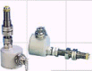

1.3 System composition and working principle
1.3.1 System composition
The system is composed of SPM gauge, SPM sensor and SPM cable. The SPM gauge is a round, wide-temperature and digitally displaying indicator. The SPM sensor utilizes un-contact measuring method, which consists of proximity type sensing switch assembly and other components. The connection cable is oil-proof, anti-corrosion and fire retardant. Connectors and plugs are water proof. The following diagram and table are for the sensor (Table 1 and Figure 1).
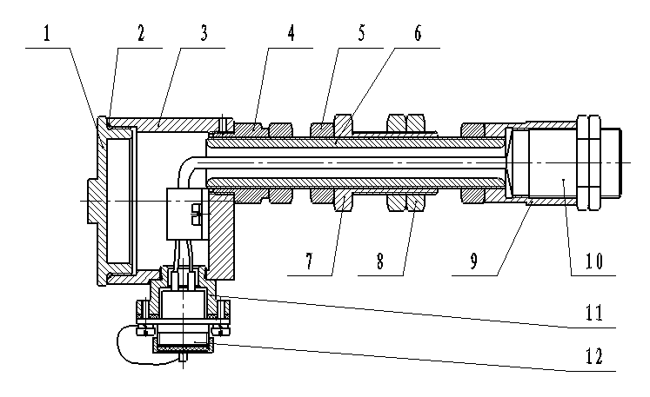
Figure 1 SPM Sensor

1 | SZJ-ZS.1-1 | Cover
2 | 2-148 | 0 ring 69.52×2.62
3 | SZJ-ZS.1-2 | Junction box
4 | SZJ-ZS.1-3 | Screw barrel
5 | SZJ-ZS.1-4 | Nut
6 | SZJ-ZS.1A-1 | Screw
7 | SZJ-ZS.1-6 | Screw barrel
8 | SZJ-ZS.1-7 | Nut
9 | SZJ-ZS.1A-2 | Probe housing
10 |  | Proximity switch
11 | SZJ-ZS.1-9 | Connector
12 |  | Four-core Socket

Table 1 Component List of SPM Sensor

1.3.2 Working principle
When a metal object passes the sensing area of the sensor, the sensor will generate a pulse signal, which is then transmitted to the signal process and display board of SPM gauge via cables. Later then processes, calculates current SPM and display. Figure 2 shows its wiring diagram.

Proximity type sensing switch
Four-core socket
Pin1：Signal
2：8.2VDC
4：Shielded cable
Blue(Signal)

Brown (Power+8.2V)

SPM

sensor

Figure 2 SPM sensor wiring diagram

1.4 Installation, adjustment and operation
1.4.1 Installation of sensor
1) SPM sensor is installed on the cover plate of crosshead of mud pump. Open the cover plate of crosshead on mud pump. Tighten a metal target through the bolt on the crosshead in the pump (or you can use the bolt as a target), and then drill a round hole (of 28mm in diameter) opposite to the target on the cover plate. Mount the SPM sensor. Turn on the pump and the crosshead will move to and fro. When the crosshead reaches its finish point, the space between the target and the sensor is within 5~10mm, as shown in Figure 3.
2) When it is necessary to adjust the space between sensor and target, and at the same time, you also have to adjust the sensor, please first open the junction box, and disconnect the wire to the sensor in case you may break the wire. Connect the wire again after completion of sensor adjustment. Users can adjust space between SPM sensor probe and target in this way if the SPM sensor is mounted on the cover plate of crosshead: Mount well SPM sensor first, and then tighten the nuts that fasten the sensor to the cover plate. Withdraw the probe; keep 1cm or more space between the probe and the crosshead. Keep the crosshead unmoved. Put back the cover plate and tighten all the screws. Be careful: the center of the probe shall be just opposite to the target. Turn inward the long screw of sensor and make the probe touch the target slightly. And then turn outward the long screw 3~5 rounds, thus keep a 5~10mm space between the sensor and the probe.
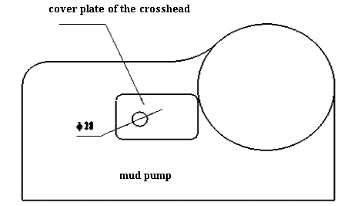
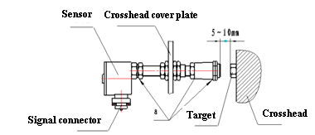

Figure 3 Installation of SPM sensor on the crosshead of mud pump

3) Apply at Position a some packing seal to prevent entering of rain into the junction box.
4) Installation of SPM sensor on the mud pump drive shaft: Weld a metal target at a proper position on the drive shaft of mud pump; drill a round hole of 28mm in the mounting bracket and make sure the hole is opposite to the target. Install the SPM sensor and keep a 5~10mm sensing distance. Rotate the drive shaft and be sure that the sensor will never touch the target. For details, refer to Figure 4
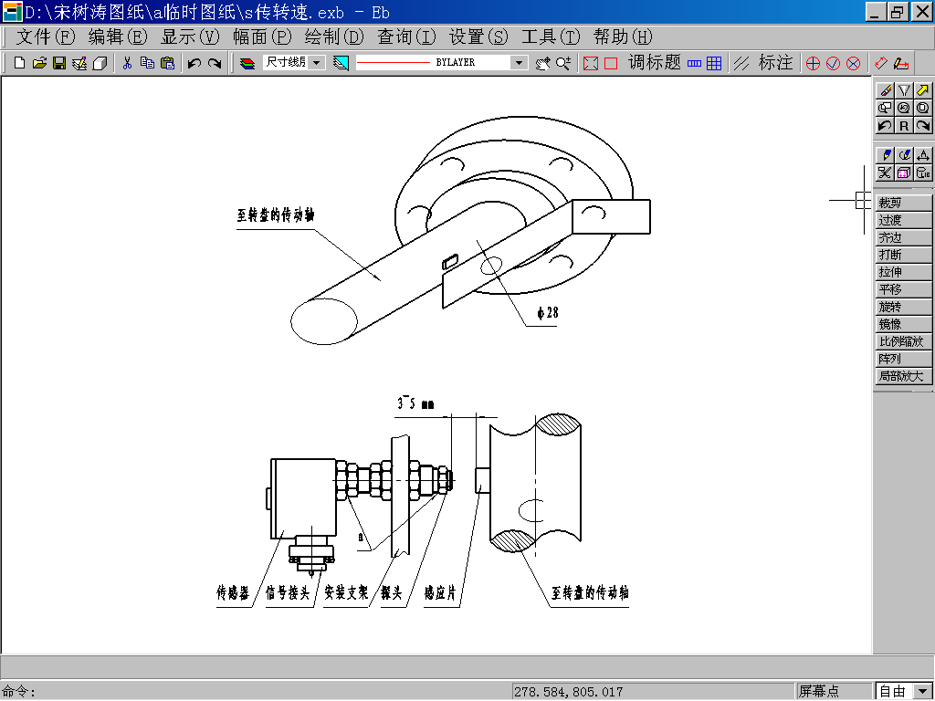
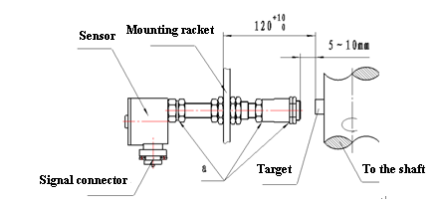

Figure 4 Installation of SPM sensor on the drive shaft of mud pump

5）Cable connection
Connect one end of the cable with sensor and the other end with the socket on the round gauge.

1.4.2 Installation of SPM gauge
Mount the total SPM gauge in corresponding position in the driller’s box or on the console and the driller can easily see it. Connect well power cable with SPM cable. Installation dimension and diagram refer to the following figures:
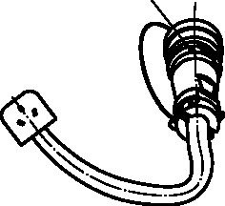
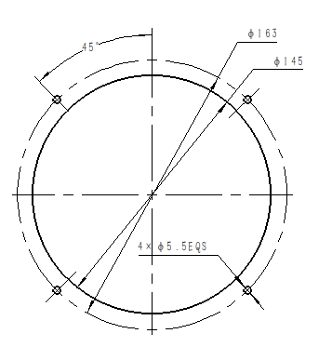 Power cable
Installation diagram of total SPM gauge

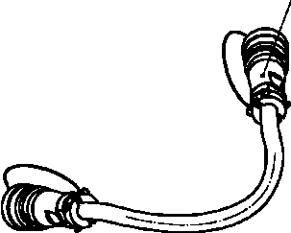
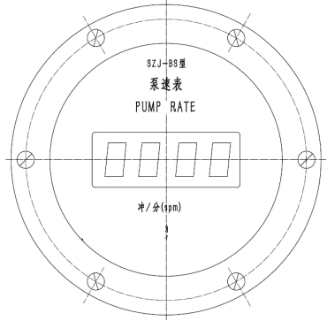 SPM Cable

1.4.3 Adjustment and operation of total SPM gauge
Internal of the total SPM gauge mainly consists of 110/220VAC power board and signal processing board. Power supply of the gauge is 110/220VAC. On the back of the indicator, there are two aerial sockets. The 3-conductor socket is used for power supply input and the four-conductor socket is for signal input. If there is a transmission ratio between the position where the sensor is installed and the pump piston, the following method can be used to set the multiplying factor of SPM:
Turn off the power supply and remove the cover of SPM gauge; the round circuit board is the signal processing and display board. On the circuit board, there is an 8-digit DIP switch (Calibration factor “A” marked on the board is the multiplying factor) of binary system. Range of multiplying factor is within 0.00~2.55. For example, it multiplying factor is supposed to be 1.00, multiply it by 100 to gain 100. Transfer it to binary system to have 64H:

Mark | 1 | 2 | 3 | 4 | 5 | 6 | 7 | 8
Setting | OFF | ON | ON | OFF | OFF | ON | OFF | OFF

If multiplying factor is set to 0.301， multiply it by 100 first to get 30.1 and then transfer it to a binary system value 1EH：
Mark | 1 | 2 | 3 | 4 | 5 | 6 | 7 | 8
Setting | OFF | OFF | OFF | ON | ON | ON | ON | OFF

On the circuit board there is also a button switch. Push the button down and the instrument will be in its working state; when the button is up, on the LCD screen, it displays multiplying factor (Display Px.x.x. Of which, x.x.x. is the factor value with two decimal points. For example, if the factor is 1, it will display P1.0.0) for you to check if the setting of multiplying factor is correct.
Calibration of total SPM gauge: when the button switch is up, the LCD displays the multiplying factor. First set Factor A as 1.00 and then press down the button switch to let the instrument in its measuring state. Start the pump and count strokes of pump in one minute and write down the value X and the displaying value Y on total SPM gauge. Use formula X/Y = Factor A to reset Value A.
After setting of multiplying factor, install the total SPM gauge cover in the reverse order of disassembly. The six screws shall be symmetrically and evenly tightened with moderate force to avoid glass breakage.

2．Maintenance and troubleshooting methods

2.1 Maintenance
a) Before moving the system, please turn off power first, and then disconnect all the cables to the sensor and put on the protecting cap.
b) Wiring of cables shall not affect normal operations. Cables shall be put in safe and reliable places, and avoid being bumped and hurt.
c) Check regularly the space between induction surface and targets, because the induction surface may be hurt when it is loosen due to vibration.
d). Check regularly the connectors for looseness and cables for breakage.
e. Do not make metal scraps or oil with metal scraps contaminate the induction surface. A contaminated surface may lead to magnetic short and in turn cause the sensor to function improperly. Try to avoid excessive exposure to the sun directly so as to improve its reliability.
6) Voltage between sensor signal end and the ground is 3.75V. If the voltage is too big, please check if the displaying value is normal.

2.2 Problems, causes and troubleshooting methods
When you have to solve SPM parameter related problems, please make sure that the signal processing and displaying board works normally. The the SPM gauge is powered, the lamp on the signal processing and displaying board glitters regulary. If not, it indicates that something is wrong with the circuit board.
Problems of inaccurate SPM display or no values displayed at all usually come from power supply, sensor itself, signal processing and displaying board, and calibration factor (suppose data acquisition board and two-path communication are in good condition).
Displaying Values of SPM Fluctuate a Lot：
1) Check corresponding cables. Shielded layer in the cable shall be ground connected at one end that is, connected to Pin 4 of aerial plug; and the other pins shall also be reliably welded.
2) Check wiring in the junction box of sensor. All the wirings shall be reliable and tight. The distance between probe of sensor and target shall not be too far or too close.
3) Check corresponding wirings gauge are reliably connected.
4) If the above mentioned methods cannot solve the problems, the signal processing and displaying board shall be replaced;

2.3 Attentions
1) Please do not take down the instrument with power on.
2) Please do not wash the instrument with water.
3) Please do not squeeze and rub the cables, replace in time the broken cables.
4) Rotation ratios of SPM have been well set at their first installation at well site. Please re-calibrate with relevant working software when they are moved.
5) No shielded cables shall go together with power cables through conduits or cable trays and all the shielded cables shall be away from equipment with high power

