Please read this manual before installation and operation

JZG15A Deadline Anchor

Operation and Maintenance Manual

1. Application Area
JZG15A Deadline Anchor is the mechanism that converts deadline load of a drilling rig into hydraulic pressure. It is one of the important parts of weight indicating system, which can be used with JZG15.1.4 sensor made by the Company to work as the primary instrument. It can also be used to make a weight indicating system, together with weight indicator and recorder.

2. Technical Specifications
a) Max. Deadline load: 150kN
b) Sensor: JZG15.1.4
c) Output pressure of deadline anchor (sensor): 6.0MPa
d) Output pressure error of deadline anchor (sensor): ±1%F.S
e) Wireline size：φ29 mm, φ26mm
f) Overall size: 910mm×625mm×330mm
g) Weight: 500kg
h) Working temperature: -20℃～+55℃

3. Structure, Installation and Maintenance
3.1 Structure:
JZG15A Deadline Anchor consists of drum, base and sensor, as shown in Figure 1.
Sensor is the key part of deadline anchor, which converts deadline load of a drilling rig into hydraulic signal by pressing the diaphragm in the sensor. The hydraulic signal is then transmitted to weight indicator and recorder. A quick female connector, a self-sealing male connector and a preserved plugging connector are installed on the sensor.

3.2 Installation
1) Fasten tightly base of the deadline anchor with bolts, nuts and washers onto the connection board of drilling rig floor.
2) Wrap the wire line round the drum 2.25 turns along the grooves of the drum, then run the wire line through the clamp, fasten it by bolt, nut and press block. The clamp and wire line must be put properly, in case sliding of deadline. Please do not let the wire line touch any other thing on the derrick.
3) Connect hand pump with the oil injection connector on the sensor. Operate the hand pump to remove gas from and inject oil into the sensor. Gas should be exhausted at the weight indicator. Operate like this: inject oil into the hydraulic system till 20%~30% full scale of weight indicator. Release gas at the gas exhaust valve. If there is gas inside the system, the oil spouts from the gas exhaust valve is un-continuous and sounds puff-puff; if there no gas in, the oil spouts from the sensor is continuous with no puff-puff sound. Repeat the operation three times and make sure all the air in the sensor is exhausted and the sensor is full of oil. Please do not pump the sensor without oil in the hand pump or air will be pumped into the sensor.
4) During oil injection and daily drilling process, check regularly if there is sufficient oil in the sensor (observe the clearance between the upper press plate and the lower plate of rubber diaphragm inside the sensor and see if it is in accordance with the condition when the sensor if fully filled.). Re-fill oil into the sensor if necessary.
5) Seat the travelling block system onto the drill platform while injecting oil or refilling oil into the sensor and make sure there is no load on the deadline anchor sensor (weight indicator) (this is very important). Remove all the air and surplus liquid and have weight indicator pointer point zero. Repeat the oil-injection and gas-removal operation three times till all the air in the hydraulic system is completely eliminated. This is one of the most important measures to ensure correct reading of the instrument.
6) Every day, before operation, clear debris, mud, and ice on the sensor, and check and see if the gap between the upper and lower press plates is normal. Observe if there is any leakage at the connection place. Solve any possible problems in time.
7) Regularly (usually 12months) apply some lubricant at the oil injection port in the drum end cap to lubricate the bearing so that it can rotate freely. Lubricant grease should be 3# high-quality lithium base grease.
8) Please use 45# transformer oil in the hydraulic system. The hydraulic oil used by the instrument should be clean and precipitation-free to prevent hose and connector from being clogged and ensure the reliable performance of the instrument.

4. Attentions
1) JZG15A Deadline Anchor must be used with JZG15.1.4 Sensor and corresponding secondary instrument (weight indicator and recorder).
2) Determine the type of drilling rig it can be used on according to the maximum deadline load.
3. Select a correct secondary instrument (weight indicator and recorder) against the number of lines of traveling block system and the maximum deadline load.
4. Bolts and relevant nuts and pads that are used to install JZG15A Deadline Anchor should be Grade 10.9.
5. The design of connecting board for deadline anchor should comply with Attached Figure 2. The detailed installation place should be determined by the rig manufacturer.

5. Spare Part List
No. | Part No. | Name | Unit | Qty. | Remarks
1 | JZG15.1.4 | Sensor | Set | 1
2 | JZG15.1.4-3 | Diaphragm | Piece | 2
3 | JY246.4.1 | Quick male connector | Piece | 1
4 | JY248.6 | Quick female connector | Piece | 1
5 | JY248.2 | Self-sealing male connector | Piece | 1
6 | JY250.2.1 | Self-sealing female connector | Piece | 1
7 | JY248-3 | O ring 12x2.4 | Piece | 4
8 | JY248.2-4 | Sealing washer | Piece | 10
9 | 2-008 | O ring 4.47×1.78 | Piece | 10
10 | JY246.4 | Long connection hose | Piece | 1 | 10m
11 | SZT5A | Hand pump | Set | 1
12 | JY250.2 | Connection hose | Piece | 1 | For hand pump，5m
13 |  | 45# transformer oil | Bottle | 2 | 2l/bottle
14 | JZG18.1-2 | Clamp | Set | 1 | Φ29, 26mm
Note: The spare parts listed here are not accessories along with the deadline anchor. They shall be ordered as needed.

5. DECLARATION：
1. The deadline anchor is forbidden to be used overload. Parts of different types must not be matched together. And we will not be liable for any INSTRUMENT DAMAGE, HUMAN HURTS, AND OTHER accidents caused by improper use!
2. WE WILL ALSO NOT BE RESPONSIBLE FOR THE QUALITY, TECHNICAL SPECIFICATIONS, TECHNICAL INTERFACE AND OTHER ASPECTS OF THE SECONDARY INSTRUMENT AND ITS SPARE PARTS THAT ARE NOT MANUFACTURED BY OUR COMPNAY!

6. aTTACHMENT:
- structral diagram
- outLINE installation diagram

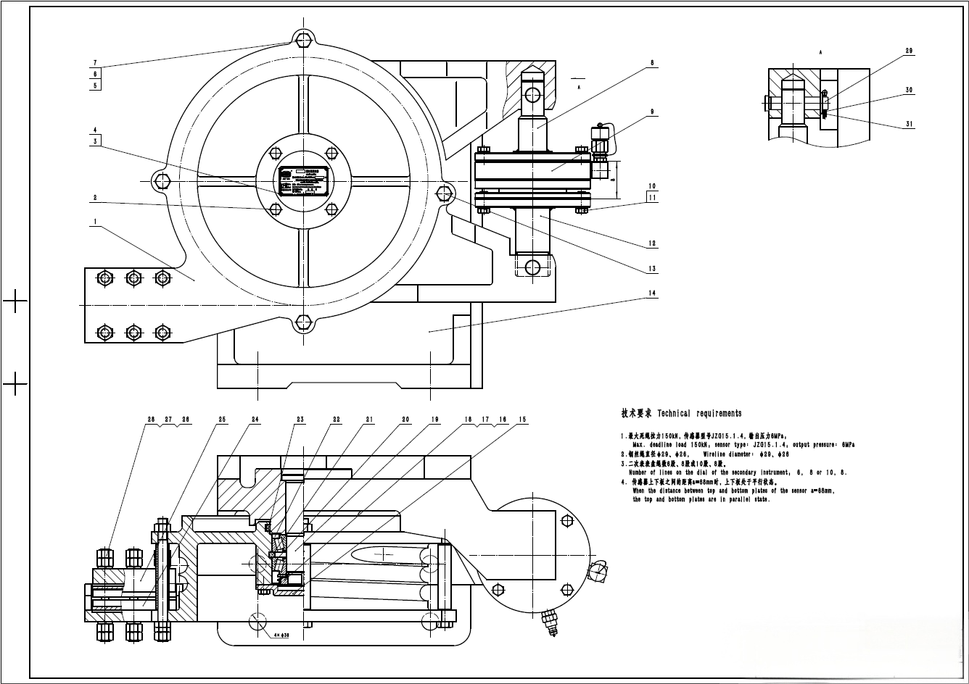
Figure 1

Structural details
No. | Part No. | Name | Qty. | Remarks
1 | JZG15.1-1 | Drum | 1
2 | GB/T 5783-2000 | Hex. Head bolt, fully threaded  M12x20-8.8 | 4
3 | JZG-MP-3 | Deadline anchor nameplate (small) | 1
4 | GB/T 827-1986 | Nameplate rivet 3x10 | 4
5 | GB/T 5782-2000 | Hex. Head bolt M16x180-8.8 | 2
6 | JZG18.1-2 | Sleeve | 4
7 | GB/T 6170-2000 | Type 1 hexagonal nut M16-8 | 2
8 | JZG15.1.3 | Upper mounting board | 1
9 | JZG15.1.4 | Sensor | 1
10 | GB/T 859-1987 | Light spring washer 12 | 8
11 | GB/T 5783-2000 | Hex. Head bolt, fully threaded M12x30-8.8 | 8
12 | JZG15.1.5 | Lower mounting board | 1
13 | GB/T 5782-2000 | Hex. Head bolt M16x160-8.8 | 2
14 | JZG15A.1-1 | Base | 1
15 | JZG18.1-9 | Bearing cover | 1
16 | GB/T 812-1988 | Round nut M56x2 | 1
17 | GB/T 858-1988 | Check washer for round nut 56 | 1
18 | JZG20.1-6 | Washer | 1
19 | JZG15A.1-2 | Shaft | 1
20 | GB/T 297-1994 | Tapered roller bearing 32212 | 2
21 | JZG18.1-11 | Expansion ring | 1
22 | GB 7324-94 | 3# lithium-based lubricating grease | 2
23 |  | Sealing ring t7x12x350 | 1
24 | JZG18.1-12 | Clamp | 1
25 | JZG18.1-13 | Pressure block | 1
26 | GB/T 901-1988 | Equal-length stud Grade B  M16x160-10.9 | 6
27 | GB/T 93-1987 | Standard spring washer 16 | 12
28 | GB/T 6170-2000 | Type 1 hexagonal nut M16-8 | 24
29 | JZG18.1-8 | Pin | 2
30 | GB/T 91-2000 | Cotter pin 5x36 | 2
31 | GB/T 95-2002 | Flat washer, Grade C 20 | 2

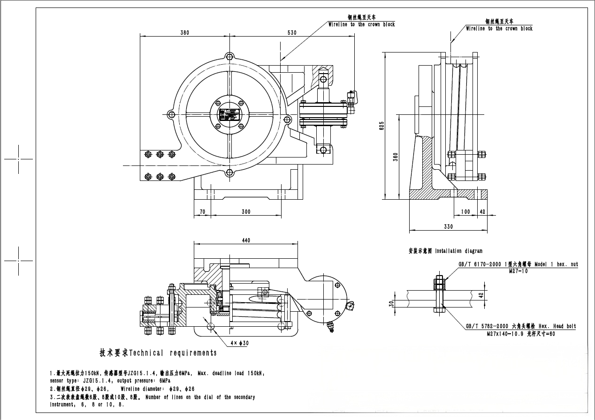
Figure 2

